Oracle Database administration Services
KE_User Account Locked Issue

Submitted to



By



CIS, Wipro Limited

Document Details

Project Name | Innogy SE
Account | CIS
IT Component/Application Title | Database Blocking
Current Version | 1.4
List of Contributors | Saurabh Nigam , Abhishek Kansal , Jiten Pansara , Ajay Zende, Sreya Puthukudy
Customer Contact Information

Version History
(All revisions made to this document must be listed in chronological order. All revisions must be approved. Review and Approval can be done by an internal source or by the customer)
Version | Date of Revision | Description | Author | Reviewed By | Approved By
1.0 | 28-08-2016 | Intial Draft | Jiten Pansara | Ajay Zende | Mahesh Keshatwar
1.1 | 04-09-2016 | Document Completed | Jiten Pansara | Saurabh Nigam | Mahesh Keshatwar
1.2 | 17-05-2017 | Wipro and Innogy Logo changed | Kamelsh Sawant | Jiten Pansara | Mahesh Keshatwar
1.3 | 21-11-2017 | Updated document to Wipro Standard format with header and footer | Abhishek Kansal | Jiten Pansara | Santosh Badiger
1.4 | 16-12-2018 | Updated the content | Sreya Puthukudy | Jiten Pansara | Santosh Badiger

Short Description:
User is unable to login database.
Problem Description:
End Users are experiencing issues while accessing database.
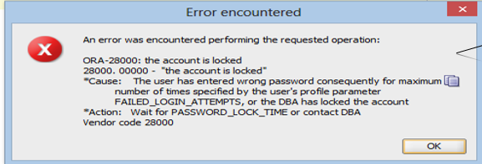
Root cause:
User might enter wrong passwords more than once hence account got locked.
Workaround:
To work around this issue, follow below steps:
- Login to the server.
- Ps –ef|grep pmon
- Login to database using sqlplus
- Check status of the user using below query.
Select username, account_status from dba_users where username=’<username>;
- If the account is locked, use below query to unlock it.
Alter user <username> account unlock;

